# Project ERD

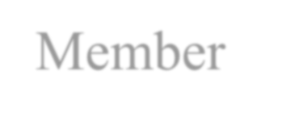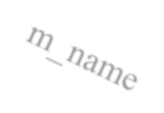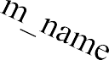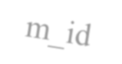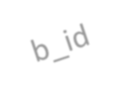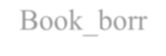

NN

Name

Quantity

Name

Book_borr

owed

Author

ID

Edition

ID

Address

Borrow

Member

b_name

Book

* **For ERD illustration:**
* Every member can register his name more than one time. In this case, we could say that the member borrow more than one book or more than a copy of the same book.
* As the same book can’t be repeated, the borrowing operation will be done on it for once. Such that the Borrow table won’t record more than one book in every operation.
* The same book cannot be borrowed by two borrowers unless one of them borrowed a copy of it.
* More than one member cannot borrow the same book at the same time.

# Project Schema



Book

|  |  |  |  |  |  |
| --- | --- | --- | --- | --- | --- |
|  | **Name** | **ID** | **Quantity** | **Author** | **Edition** |
|  |
| Member | | | | | |
|  | **Name** | **ID** | **Address** | **Book_borrowed** |  |
|  |

Borrow

|  |  |  |  |
| --- | --- | --- | --- |
| **m_name** | **m_id** | **b_name** | **b_ID** |

# Project Mapping

* + The mapping for this project are being performed by Microsoft access.

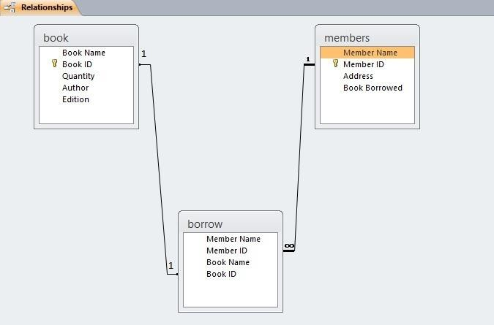

**Project Team Members**

**.1 علي محمد عبدالعزيز Leader) (Team**

**.2 عبدالرحمن احمد محمد انور**

**3. عمر حسن صبري**

**.4محمد احمد طه**